- Experiment (a)

Aim:
To simulate the dominant TE₁₀ mode of a WR-90 rectangular waveguide using HFSS at an operating frequency of 10 GHz, obtain the E-field and H-field distributions, determine the simulated cutoff frequency and propagation constant, and compare the simulated cutoff frequency with the theoretical value.

Procedure:
- Open ANSYS HFSS and create a new electromagnetic design.
- Set the model units to mm.
- Draw a rectangular waveguide with:
- Width a=22.86a=22.86 mm
- Height b=10.16b=10.16 mm
- Length L=100L=100 mm.
- Assign Perfect E (PEC) boundary conditions to the four metallic walls.
- Define the two end faces as wave ports.
- On the input port, assign the TE₁₀ mode as the dominant excitation mode.
- Set the solution frequency to 10 GHz.
- Create an appropriate frequency sweep around the operating frequency to identify the cutoff behavior.
- Generate the HFSS mesh and run the simulation.
- Plot the electric-field distribution using:

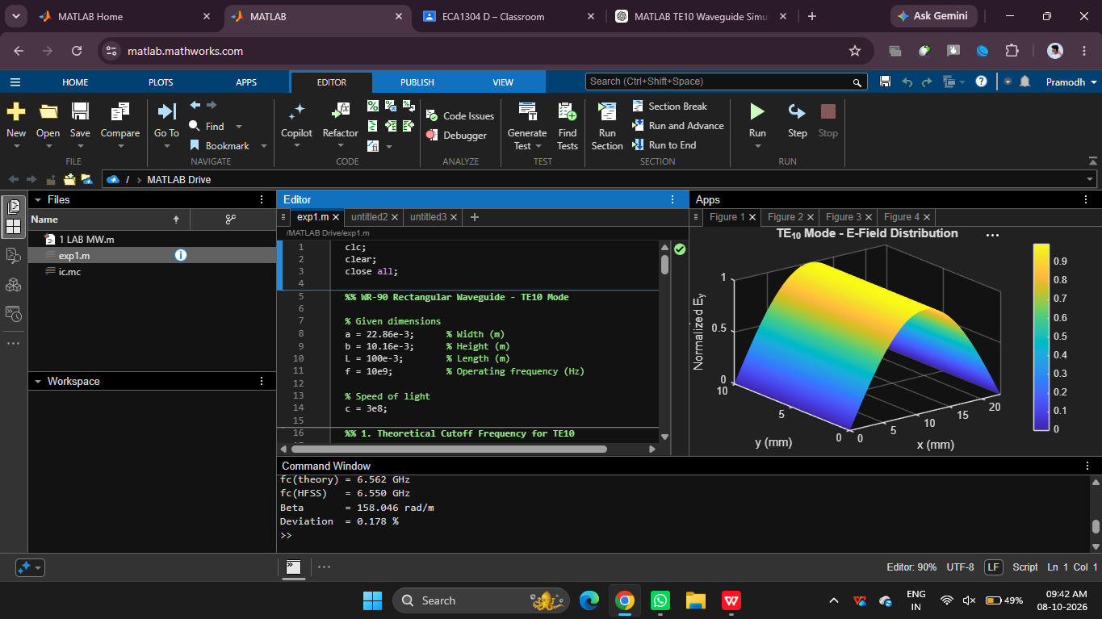

Result:
The WR-90 rectangular waveguide was successfully simulated in HFSS at 10 GHz using the dominant TE₁₀ mode. The E-field and H-field distributions were obtained and showed the expected TE₁₀ field pattern.

(b)
Aim:
To simulate and compare the TE₁₀ and TM₁₁ modes of a WR-90 rectangular waveguide at 10 GHz using HFSS, determine their cutoff frequencies fcf_c, propagation constants β\beta, and E/H-field distributions, and verify why TE₁₀ propagates while TM₁₁

Procedure:

Procedure
- Open ANSYS HFSS and create a new electromagnetic design.
- Set the model units to mm.
- Draw a rectangular waveguide of dimensions:
  - a=22.86a=22.86 mm
  - b=10.16b=10.16 mm
  - L=100L=100 mm.
- Assign Perfect E/PEC boundary conditions to the four conducting walls.
- Assign wave ports at the input and output faces.
- For the first simulation, select the TE₁₀ mode at the input port.
- Set the operating frequency to 10 GHz and run the simulation.
- Obtain the E-field distribution and H-field distribution from the HFSS field plots.
- Determine the cutoff frequency fcf_c and propagation constant β\beta for TE₁₀.
- Repeat the simulation by exciting the TM₁₁ mode.
- Obtain the corresponding E-field and H-field distributions and determine whether the mode propagates at 10 GHz.
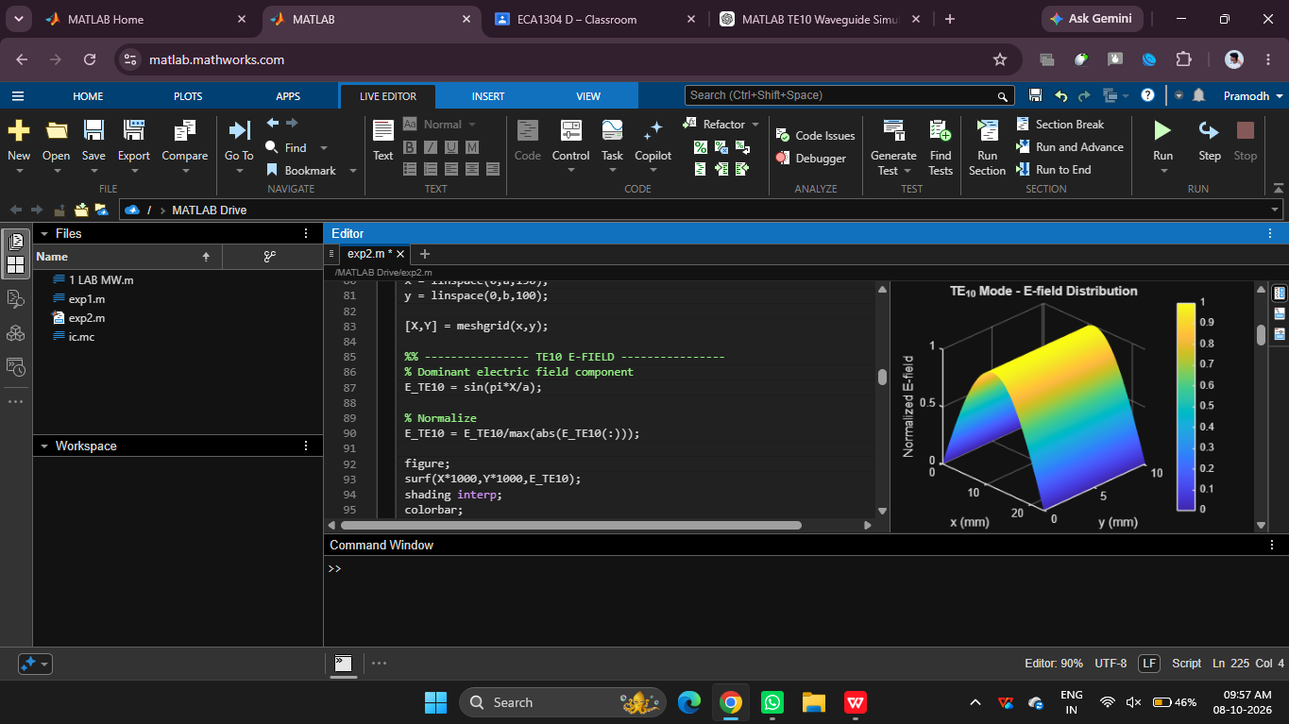

Result:
The TE₁₀ and TM₁₁ modes of the WR-90 rectangular waveguide were analyzed at 10 GHz.
The theoretical results are:
fc,TE10=6.56 GHz\boxed{f_{c,TE10}=6.56\text{ GHz}} βTE10​≈168 rad/m

